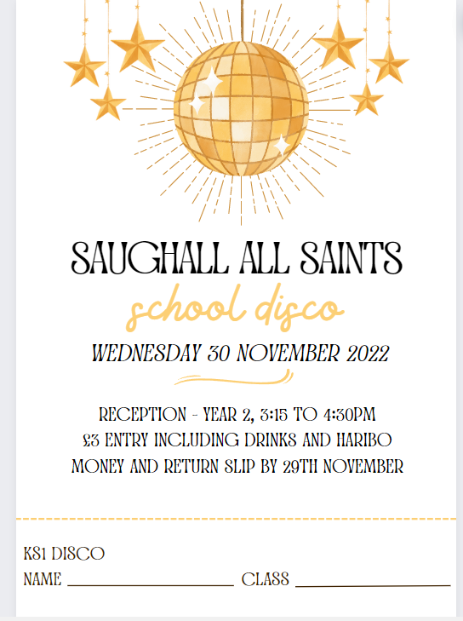

Saughall All Saints

School Disco

*Thursday 9th January 2025*



Year 3-6, 4.45 to 6.00pm

£3 Entry including drinks and sweets

**Pay on Entry**

(Bring extra money for sweets – Max £1.50)