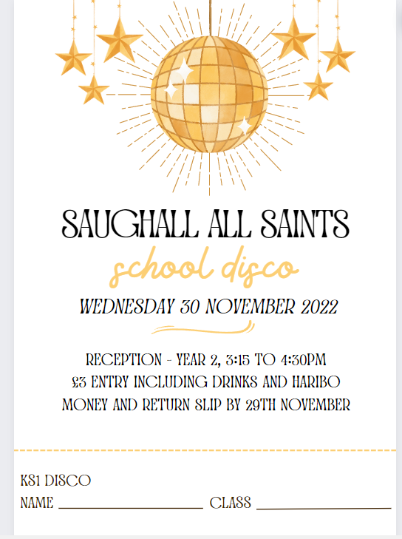

Saughall All Saints

School Disco

*Thursday 9th January 2025*

Reception – Year 2, 3.15 to 4.30pm

£3 Entry including drinks and sweets

Money and Return Slip by Tuesday 7th January

---------------------------------------------------------

KS1 Disco

Name_______________________________________________ Class_________________________________



Saughall All Saints

School Disco

*Thursday 9th January 2025*

Reception – Year 2, 3.15 to 4.30pm

£3 Entry including drinks and sweets

Money and Return Slip by Tuesday 7th January

---------------------------------------------------------

KS1 Disco

Name_______________________________________________ Class_________________________________