**Saughall All SC:\Users\sch8752014\AppData\Local\Microsoft\Windows\Temporary Internet Files\Content.IE5\E026O3OE\art_material[1].gifaints Primary School**

|  |  |  |
| --- | --- | --- |
| **Literacy**  We will begin by working on the basics of writing including capital letters and full stops and creating sentences that make sense. We will also be working on handwriting ensuring that children are using slopes and flicks when forming their letters.  As well as this, we will be working on non-fiction writing focusing on our topic, The Great Fire of London. The children will get the chance to write a diary entry as Samuel Pepys did at the time of the fire. | **Mathematics**  The children will be reading and writing numbers as numerals and words, continuing number patterns, and using place value to partition and make 2 digit numbers. The year 1 children will also begin to count in steps of 2 and 10. Whilst the year 2 children will consolidate this counting they will also be counting in 5’s and beginning to count in 3’s and relate these to multiplication. They will also be looking at the place value of numbers. | **Computing**  We will begin this term by learning about data and information. The children will be grouping objects and using labels, comparing groups and asking questions.  Following this, the children will begin to understand the importance of organising data effectively for counting and comparing. They will create their own tally charts to organise data, and represent the tally count as a total. |
| **RE**  This half term the children will be able to explain how Christians view the creation of the world and try to take care of it (stewardship) and explain how a Humanist understands how they can make the world a better place. | **PHSE**  We will be making the classroom our own this half term by devising a class charter to follow throughout the year. We will also focus on our mental health, talking about our feelings and encouraging the children to talk about these feelings. | **Trips and visits**  We will be going on a trip to Weaver Hall on Monday 7th and Tuesday 8th October. This links to our topic of the Great Fire of London. You will have already received a letter to inform you which day your child will be attending and the cost. |
| **Additional information**  In Key Stage 1 we are looking at making the children as independent as possible. In doing this, the children will be expected to be ready for their lessons, follow instructions and collect all their own home time things together. We would appreciate your support with this at home by allowing your child a little more time in the mornings to dress themselves, put on their own coat and zip it up and do some simple tasks independently. Please remember your child’s water bottle and book bag every day. | | |

**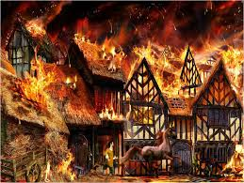C:\Users\sch8752014\AppData\Local\Microsoft\Windows\Temporary Internet Files\Content.IE5\E026O3OE\art_material[1].gifC:\Users\sch8752014\AppData\Local\Microsoft\Windows\Temporary Internet Files\Content.IE5\E026O3OE\art_material[1].gif**

**Scientist**

As a scientist I will be investigating

* Materials and their properties;
* Observing materials in my environment and the outside environment.
* How materials can change when heated or cooled.

**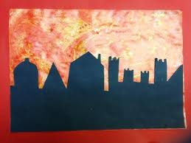**

**Historian**

As an historian I will be learning about

* Where and when the Great Fire started;
* Events that happened during the fire;
* The diary written by Samuel Pepys at the time of the fire.

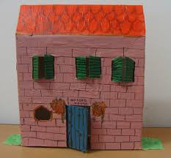

**Design and Technology**

As a designer I will be learning

* To design, make and evaluate a home;
* About different types of homes, including semi-detached, detached, bungalow and terraced houses.

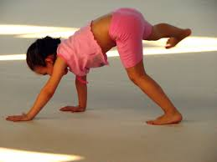

**Musician**

As a musician I will be learning

* To listen and appraise different styles of music;
* To keep a steady beat (pulse);
* To learn and perform new songs.

**Sports personC:\Users\sch8752014\AppData\Local\Microsoft\Windows\Temporary Internet Files\Content.IE5\E026O3OE\art_material[1].gif**

As a sports person I will be learning

* To look for space in gymnastics, balance, roll and travel in different ways and link my moves;
* To work as a team;
* Learn new rugby skills.