Meet Our Governors
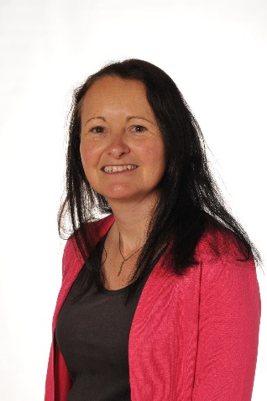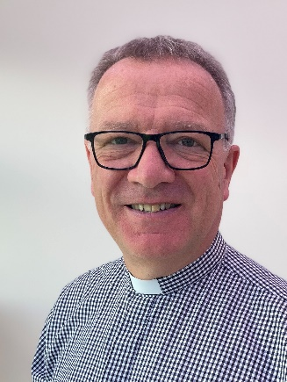
Nicola Stewart Helen Owen Steve Mansfield
Co-Chair of Governors Parent Governor Foundation Governor
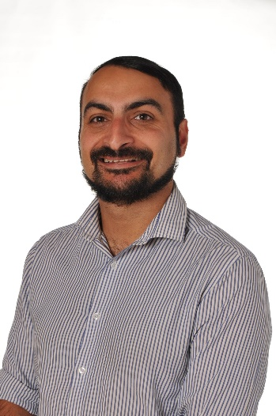
Ian Carroll Daniel Franklin Doug Annan
Parent Governor Co-Opted Governor Co-Opted Governor
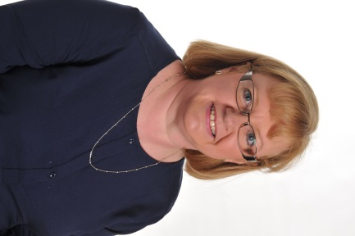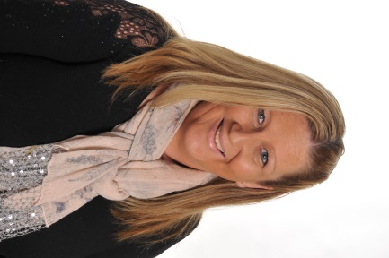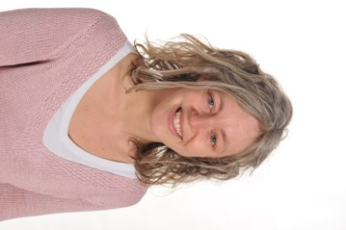
Donna Prenton Gemma Cook Ellie Fabby
Staff Governor (Head Teacher) Co-Opted Governor Staff Governor

