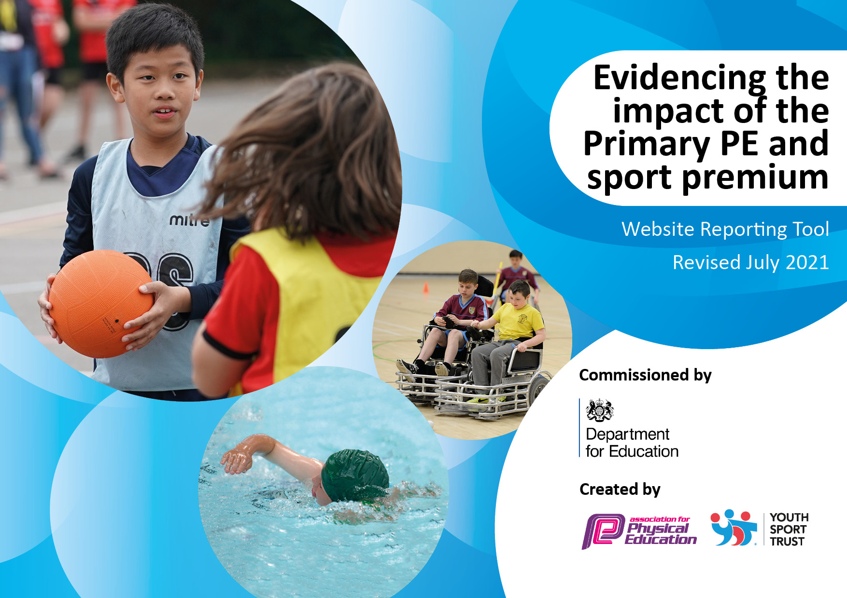
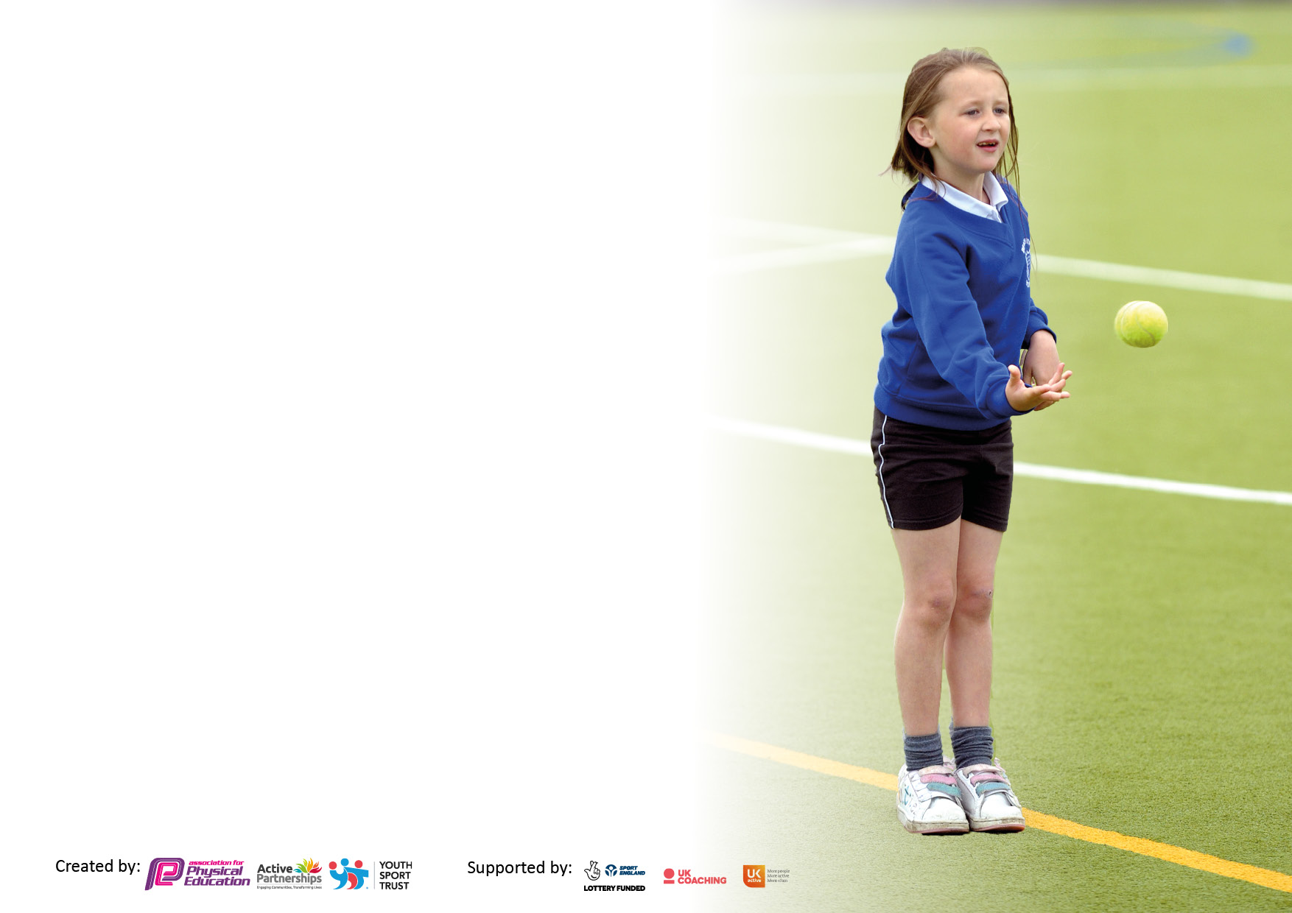

It is important that your grant is used effectively and based on school need. The Education Inspection Framework makes clear there will be a focus on ‘whether leaders and those responsible for governors all understand their respective roles and perform these in a way that enhances the effectiveness of the school’.

Under the Quality of Education Ofsted inspectors consider:
Intent - Curriculum design, coverage and appropriateness
Implementation - Curriculum delivery, Teaching (pedagogy) and Assessment
Impact - Attainment and progress

To assist schools with common transferable language this template has been developed to utilise the same three headings which should make your plans easily transferable between working documents.

Schools must use the funding to make additional and sustainable improvements to the quality of Physical Education, School Sport and Physical Activity (PESSPA) they offer. This means that you should use the Primary PE and sport premium to:

- Develop or add to the PESSPA activities that your school already offer
- Build capacity and capability within the school to ensure that improvements made now will benefit pupils joining the school in future years
- The Primary PE and sport premium should not be used to fund capital spend projects; the school’s budget should fund these.

Pleasevisitgov.ukfortherevisedDfEguidanceincludingthe5keyindicatorsacrosswhichschoolsshoulddemonstrate animprovement.Thisdocumentwillhelpyoutoreviewyourprovisionandtoreportyourspend.DfEencouragesschools to use this template as an effective way of meeting the reporting requirements of the Primary PE and sport premium.

We recommend you start by reflecting on the impact of current provision and reviewing the previous spend.

Schools are required to publish details of how they spend this funding, including any under-spend from 2019/2020, as well as on the impact it has on pupils’ PE and sport participation and attainment. All funding must be spent by 31st July 2023.

We recommend regularly updating the table and publishing it on your website throughout the year. This evidences your ongoing self-evaluation of how you are using the funding to secure maximum, sustainable impact. Final copy must be posted on your website by the end of the academic year and no later than the 31st July 2021. To see an example of how to complete the table please click HERE.
Created by: Supported by:

Details with regard to funding
Please complete the table below.

Total amount carried over from 2021/22 | £ 0
Total amount allocated for 2021/22 | £18,228
How much (if any) do you intend to carry over from this total fund into 2022/23? | £0
Total amount allocated for 2022/23 | £18,150
Total amount of funding for 2022/23. To be spent and reported on by 31st July 2023. | £18,730.54
Swimming Data
Please report on your Swimming Data below.

Meeting national curriculum requirements for swimming and water safety.

N.B. Complete this section to your best ability. For example you might have practised safe self-rescue techniques on dry land which you can then transfer to the pool when school swimming restarts.
Due to exceptional circumstances priority should be given to ensuring that pupils can perform safe self rescue even if they do not fully meet the first two requirements of the NC programme of study
What percentage of your current Year 6 cohort swim competently, confidently and proficiently over a distance of at least 25 metres?  N.B. Even though your pupils may swim in another year please report on their attainment on leaving primary school at the end of the summer term 2023.  Please see note above | 100%
What percentage of your current Year 6 cohort use a range of strokes effectively [for example, front crawl, backstroke and breaststroke]?  Please see note above | 90%
What percentage of your current Year 6 cohort perform safe self-rescue in different water-based situations? | 100%
Schools can choose to use the Primary PE and sport premium to provide additional provision for swimming but this must be for activity over and above the national curriculum requirements. Have you used it in this way? | Yes – water based activities on outward bound residential

Action Plan and Budget Tracking
Capture your intended annual spend against the 5 key indicators. Clarify the success criteria and evidence of impact that you intend to measure to evaluate for pupils today and for the future.

Academic Year: 2022/23 | Total fund allocated: | Date Updated: July 2023
Key indicator 1: The engagement of all pupils in regular physical activity – Chief Medical Officers guidelines recommend that primary school pupils undertake at least 30 minutes of physical activity a day in school |  |  |  | Percentage of total allocation:
Intent | Implementation |  | Impact
Your school focus should be clear what you want the pupils to know and be able to do and about  what they need to learn and to  consolidate through practice: | Make sure your actions to achieve are linked to your intentions: | Funding allocated: | Evidence of impact: what do pupils now know and what can they now do? What has changed?: | Sustainability and suggested next steps:
To engage children in active play at lunchtime, active brain breaks as well as offering 2 hours of timetabled PE each week.  To engage pupils in active extracurricular sports and dance activities. | Sports coach employed on KS2 playground to lead active and organised sports each lunchtime play.  All classes to complete laps of the bark as an active challenge. How many laps can you compete in a week as a whole class?  2 externally run sports/dance clubs after school in addition to school run sports clubs throughout the year to match the competition programme led by CSSP. | 5 x 1 hour/week sports coach on KS2 playground | Summer term 2022:  Total number of pupils benefiting from specialist sports coaching per week: 143 pupils across KS2  Total number of pupils benefitting from after school sports provision per week: 177 pupils across R-Year 6.  All pupils take part in two curriculum PE lessons a week with either a sports specialist coach or their own class teacher as well as having the opportunity to attend 7 different sports and active clubs each week.
Key indicator 2: The profile of PESSPA being raised across the school as a tool for whole school improvement |  |  |  | Percentage of total allocation:
 |  |  |  | 85%
Intent | Implementation |  | Impact
Your school focus should be clear what you want the pupils to know and be able to do and about  what they need to learn and to  consolidate through practice: | Make sure your actions to achieve are linked to your intentions: | Funding allocated: | Evidence of impact: what do pupils now know and what can they now do? What has changed?: | Sustainability and suggested next steps:
Pupils are taught the knowledge, understanding and skills needed to engage in the process of physical, cognitive and social and emotional activities.  Physical Education Intent  At Saughall All Saints we want our children to love physical education and sport. We want them to have no limits to what their ambitions are and grow up wanting to be personal trainers, nutritionists, sports journalist or gold medal winners. Our aim to ensure that every child has the opportunity to access at least 60 minutes of physical activity a day, while covering all aspects of the PE national curriculum. We believe, through experiences and a broad, balanced and progressive curriculum tailored to all children, they will continue to have the motivation, confidence, physical competence, knowledge and understanding to value and take responsibility for their engagement in physical activity, sport and PE. Our intention is to develop a lifelong love of physical activity, sport and PE for every child at Saughall. We help all children to make rapid progress in their physical, social and mental development. This helps them maintain a positive physical and mental outlook for the future. We want to teach children skills to keep them safe such as being able to swim. We also want to teach children how to cooperate and collaborate with others as part of an effective team, understanding fairness and equity of play to embed life-long values. Our curriculum aims to improve the wellbeing and fitness of all children at Saughall All Saints, not only through the sporting skills taught, but through the underpinning values and disciplines PE promotes. | Children at Saughall All Saints undertake weekly PE sessions, taught by their class teacher.  - Our use of PE coaches, also ensure that our children receive quality first provision in all year groups during lunchtimes also. This also provides excellent CPD for staff as they observe and take part in the lessons delivered by specialist sports coaches.  - We also have specialist PE coaches who work within EYFS to support the children’s physical development, focusing on improving core strength and fine and gross motor skills (Wirral Rugby Tots).  - All children have the access to an inclusive curriculum. Support is provided for SEND children in line with other subjects and learning is differentiated meaning every child accesses consistent opportunities and input across the school.  - Lessons focus on improvement in performance, competition and social and mental development.  - A progression of skills is used with each year group, which enables pupils to build on and develop their skills each year for each area, with regular assessments in each lesson. The children’s progress in PE is accessible by all teachers meaning they can view the Foundation Assessment Tracker which is continued year to year. This means all teachers have an active role in promoting the profile of physical activity, sport and PE.  Our lunchtimes at Saughall are an important time for children to engage in physical activity and for all children to access to opportunity to engage in at least 60 minutes of physical activity a day. There is a weekly sport rota which is followed by all lunch time supervisors and supported by our PE coach (KS2 playground) and Year 6 playground leaders (KS1 playground). This allows our children to have a broad and well-rounded opportunity to engage in physical activity.  All children at Saughall All Saints, have access to a variety of extracurricular activities such as after school clubs 3 days a week and tournaments.  Children have the opportunity to participate in a wide range of competitions. Our participation and success in sporting events raise the profile of PE further and creates even more enjoyment of physical activity. This links in with our intent of allowing all our children to be physically active for life and understand the benefits of this.  - Children in Year 3-6 participate in a swimming curriculum for approximately 6 weeks a year. This is essential in teaching them this important life skill as well as life saving techniques. Children in Year’s 2, 4 and 6 are invited to attend a residential trip where they will undertake various outdoor activities such as orienteering, damn building, archery, abseiling, climbing, canoeing, gorge walking, and high ropes. | (see indicator 3) | See overview of skills progression below.
Overview - Skills progression - Physical Education
Pupils are taught the knowledge, understanding and skills needed to engage in the process of physical, cognitive and social and emotional activities.
Below are the skills and end points for each phase.

EYFS
Children at the expected level of development will:
- Experiments with different ways of moving.
- Jumps off an object and lands appropriately.
- Negotiates space successfully when playing racing and chasing games with other children, adjusting speed or changing direction to avoid obstacles.
- Shows some understanding that good practices with regard to exercise, eating, sleeping and hygiene can contribute to good health.
- Travels with confidence and skill around, under, over and through balancing and climbing equipment.
- Shows understanding of the need for safety when tackling new challenges, and considers and manages some risks.
- Shows increasing control over an object in pushing, patting, throwing, catching or kicking it.
- Shows understanding of how to transport and store equipment safely.
- Practices some appropriate safety measures without direct supervision.
- Shows a preference for a dominant hand.
- Children show good control and co-ordination in large and small movements.
- They move confidently in a range of ways, safely negotiating space.
- Children know the importance for good health of physical exercise, and a healthy diet, and talk about ways to keep healthy and safe.
 | Year1/2 |  | Year 3/4 |  | Year 5/6
Physical Domain | By the end of year 1 pupils should be able to:  - Copy single movements and skills with a reasonable degree of accuracy and developing control  - Perform simple dances using simple movement patterns, with prompts  - Send and receive a variety of objects with developing control  - Demonstrate good static balance across a range of different body shapes and positions and using bases of varying sizes  - Begin to develop simple dynamic balance  - Move in a range of different ways with increasing control  By the end of year 2, pupils should be able to:  - Move confidently in a range of different ways, linking together simple actions with control.  - Perform a short series of actions/movements with some changes in level, speed and direction  - Show good dynamic balance in a range of different contexts  - Show good co-ordination skills to throw, catch, strike, bounce, trap and kick a variety of objects in different contexts  - Begin to apply simple physical skills in team games  - Create and perform simple dances using simple movement patterns |  | By the end of year 3, pupils should be able to:  - Use a broad range of movement skills with control and consistency and relevant to the learning context.  - Begin to use fundamental movement skills in combination in sequences and in small game situations  - Begin to use skills effectively to execute simple attack and defence strategies in a range of modified game situations  By the end of year 4, pupils should be able to:  - Use fundamental movement skills in combination and with increasing confidence  - Combine movements in different ways to produce different outcomes  - Apply their skills in a range of modified game situations  - Use skills effectively to execute simple attack and defence strategies in a range of modified game situations |  | By the end of year 5, pupils should be able to:  - Use a wide range of different movements in combination, maintaining good control, in a range of small sided game situations.  - Begin to adapt the performance of different movements to meet the outcomes required  - Develop increasingly complex sequences of movements  By the end of year 6, pupils should be able to:  - Combine complex sequences of actions with quality and fluency  - Show confidence in adapting movements and skills to meet a specific outcome  - Apply their skills confidently in a range of sport specific contexts
Cognitive Domain | By the end of year 1 pupils should be able to:  - Understand and follow simple rules  - Use appropriate vocabulary to talk about what they are doing  - Provide simple feedback to a partner on a specific focus  - Observe and copy others  - Identify appropriate movements to link to a given theme  - Follow simple instructions to achieve a task  By the end of year 2, pupils should be able to:  - Describe what he/ she or a partner is doing using key words  - Remember and repeat simple movements and short patterns  - Begin to use simple strategies for attacking and defending eg: dodging, moving or sending into space  - Begin to apply skills in a range of different activity areas  - Create simple games and activities and identify the rules needed to make them successful  - Describe different movements using key words  - Select and link simple, appropriate movements to a given theme  - Create and perform simple dances using simple movement patterns |  | By the end of year 3, pupils should be able to:  - Apply physical skills with increasing confidence in a range of different activity areas  - Show an understanding of simple attacking and defending strategies  - Identify similarities in their own and others’ work  - Identify which actions are harder / easier  - Use given success criteria to identify what they can do well and begin to suggest areas for improvement  - Develop sequences of movement that express their own ideas  By the end of year 4, pupils should be able to:  - Use an awareness of space and others to make good decisions  - Describe what they can do well and suggest areas for improvement  - Identify why one action / series of actions is more effective than another using given criteria for success  - Respond creatively in different situations by adjusting skills or tactics to achieve a successful outcome |  | By the end of year 5, pupils should be able to:  - Explain clearly how to develop their own and others’ work  - Formulate strategies to outwit opponents  - Identify aspects of their own performance that need to be improved and explain how  - Use a variety of skills and techniques creatively to engage an audience  - Plan and organise how to use skills and techniques to produce increasingly successful responses to a task  By the end of year 6, pupils should be able to:  - Make effective judgements about the quality of a performance against a number of set criteria  - Identify key strengths and weaknesses of their own and others’ performances and know how to improve  - Compare the complexities of different compositional elements, skills or tactics and how they affect performance  - Choreograph simple sequences / dances for themselves and others  Change their tactics in response to the actions of their opposition
Social and Emotional Domain | By the end of year 1 pupils should be able to:  - Understand key safety principles eg: using equipment safely, moving and landing safely  - Work independently on simple tasks, for short periods, asking for help when needed  - Work with a partner, sharing and taking turns  - Listen to feedback from a partner  - Watch while someone shows them an action  - Show an awareness of why exercise is good for health  Say how their bodies feel before, during and after exercise  By the end of year 2, pupils should be able to:  - With encouragement, persist when learning is challenging and understand the importance of practice  - Work independently and have a range of strategies for accessing help when needed  - Support and encourage others with their work  - Have the confidence to share their work and ideas and listen to others do the same.  - Work with a partner to plan and review work  - Describe how their bodies change before, during and after exercise  Explain why it is important to warm up and cool down |  | By the end of year 3, pupils should be able to:  - Recognise where they are with their learning and challenge themselves  - Persevere with challenging tasks and react positively when things are difficult  - Co-operate with others on simple tasks and give and receive feedback  - Work effectively in small groups where roles are clearly defined  - Recognise when others are finding tasks challenging and provide support and encouragement  - Describe the basic fitness components  - Explain how often and how long they should exercise to be healthy  Record and monitor how hard they are working  By the end of year 4, pupils should be able to:  - Identify and describe their own strengths and weaknesses  - Set appropriate and challenging targets for themselves  - Contribute to organising roles and responsibilities within a small group  - Guide a small group through a simple task  - Select and perform their own warm up and cool down activities, appropriate to the activity  Explain how different activities help develop the different components of fitness |  | By the end of year 5, pupils should be able to:  - Receive constructive feedback and use it to improve their performance  - Challenge feedback appropriately and express a different perspective  - Give feedback in a constructive and sensitive manner to improve their own performance and that of others  - Negotiate and collaborate effectively with others, in a range of contexts  - Plan simple activities for themselves and others that will enable them to improve their fitness or specific aspects of their performance  Identify the possible dangers when planning an activity  By the end of year 6, pupils should be able to:  - Create their own learning plan and revise it when necessary  - Make appropriate decisions about how to further their own learning and that of others  - Lead a group to achieve a successful outcome in a range of different activities  - Involve and motivate others to perform better  Explain how different individuals need different types and levels of fitness to be more effective in their activity / role / event
Vocabulary | Dance  Travel  Stillness  Direction  Space  Body parts  Levels  Gymnastics:  Forwards  Backwards  Sideways  Roll  Slow  Body parts  Shape  Jump  Travel  Stretch  Wide  Narrow | Games  Speed  Striking  Catching  Own space  Team  Speed  Direction  Passing  Controlling  Shooting  Scoring | Dance  + Space  Repetition  Action and reaction  Pattern  Gymnastics:  stretch  push  pull  step  spring  crawl  still  slowly  tall  long  forwards  high  low  roll  copy  jump  land  balance | Games:  Keep possession  Scoring goals  Keeping score  Making space  Pass/send/receive  Travel with a ball  Make use of space  Points/goals  Rules  Tactics  Batting  Fielding  Defending  Hitting | Dance:  + Dance style  Technique  Pattern  Rhythm  Variation  Unison  Canon  Action  Reaction  Gymnastics:  Muscles  Joints  Symmetrical/asymmetrical  Rotation  Turn  Shape  Landing  Take-off  Flight  Performance/evaluation | Games:  Keeping possession  Passing  Dribbling  Shooting  Support  Marking  Attackers/defenders  Marking  Team play  Batting  Fielding  Bowler  Defending  Hitting  Offside  Pitch  Forehand/backhand

Key indicator 3: Increased confidence, knowledge and skills of all staff in teaching PE and sport |  |  |  | Percentage of total allocation:
 |  |  |  | 85%
Intent | Implementation |  | Impact
Your school focus should be clear | Make sure your actions to | Funding | Evidence of impact: what do | Sustainability and suggested
what you want the pupils to know | achieve are linked to your | allocated: | pupils now know and what | next steps:
and be able to do and about | intentions: |  | can they now do? What has
what they need to learn and to |  |  | changed?:
consolidate through practice:
Sports coaches to deliver high quality curriculum sessions in different sports, including rugby, swimming, badminton, dance and cricket. | All teachers will undertake CPD throughout the year by observing and participating in weekly PE lessons planned and delivered by specialist sports coaches and our dance teacher. | £10,655 - CEPD  £3491.94- HoD  £1950 – Wirral Rugby Tots | Improved knowledge and confidence in teaching PE.  Sports coaches to deliver Rugby, cricket, basketball, badminton, hockey, athletics and football. | Continued funding required to sustain this excellent level of CPD.
Key indicator 4: Broader experience of a range of sports and activities offered to all pupils |  |  |  | Percentage of total allocation:
 |  |  |  | 57%
Intent | Implementation |  | Impact
Your school focus should be clear | Make sure your actions to | Funding | Evidence of impact: what do | Sustainability and suggested
what you want the pupils to know | achieve are linked to your | allocated: | pupils now know and what | next steps:
and be able to do and about | intentions: |  | can they now do? What has
what they need to learn and to |  |  | changed?:
consolidate through practice:
To introduce a range of different sports that children may not experience outside of the school PE curriculum. | Children to participate in the following activites delivered by external sports coaches:  KS1 – Rugby Tots  KS1 – Chester FC  KS2 – Badminton  KS2: Cricket  KS2 - Basketball  KS1 and KS2 -- Dance  KS2 – orienteering, canoeing, abseiling, paddle boarding, kayaking, climbing wall.  KS2 - Athletics and cross country - | (see indicator 3)  Plus:  Cheshire Phoenix - £350 | Year 2, 4 and 6 pupils attend an outward-bound focus residential trip (subsidised by school).  Children to experience different sports and school to sign post children to local clubs to pursue their interest. Eg. West Cheshire Athletics, Cheshire Phoenix Basketball, House of Dance, Specialist Badminton coaching.

Key indicator 5: Increased participation in competitive sport |  |  |  | Percentage of total allocation:
 |  |  |  | 10%
Intent | Implementation |  | Impact
Your school focus should be clear | Make sure your actions to | Funding | Evidence of impact: what do | Sustainability and suggested
what you want the pupils to know | achieve are linked to your | allocated: | pupils now know and what | next steps:
and be able to do and about | intentions: |  | can they now do? What has
what they need to learn and to |  |  | changed?:
consolidate through practice:
School sports teams will participate in Level 2 (and Level 3) games as a member school of the CSSP and CEPD.  School will provide opportunites for pupils to participate in a Competition Dance Squad (Year 5/6) | Member of CSSP  Member of CSSA – Level 2 competitions  HoD – to deliver high quality dance lessons to all pupils and specific dance lessons to a competition squad in Year 5/6. (39 weeks of 1 afternoon teaching/week) | £1500 (member school of CSSP)  £200  £3491.94  £600 (transport for Regional Dance competition) | 2022/23 – Year 6 Boys WCAC Primary School series - Champions.  2022/23 – SEND inclusion festival – Boccia and New Age Kurling (KS2)  2022/23 – Y5/6 Cheshire Phoenix Hoops4Health Basketball Runners up  2022/23 – Y5/6 Hockey (2nd in the group)  2022/23 – Chester Schools Sportshall Atheltics Champions and County Silver medallists.  2022/23 – KS1 – 10 week programme for all children delivered by Rugby Tots.  2022/23 – EYFS, Y3/4 and Y5/6 – 5 week programme for all children delivered by Cheshire Cricket coach as part of the Westminster project and The Chance to Shine Programme.  2022/23 – Year 5/6 Chester schools Football League runners up.  2022/23 – Netball - This year in netball we have catered for year groups 4-6. In total 46 children have attended the club throughout the year.  We have taken part in the Chester school’s High 5 tournament (coming runners up) and the Chester School’s 7 a side tournament where we took an a&b team (the a team won the tournament).  We have one SEN child and a pupil premium child who have taken part in the tournaments.  In addition to this, throughout June we have had a North West Panthers coach take our netball club for 4 weeks.  2022/23 – Chester schools Rounders semi-finallists  2022/23 – Regional Dance Champions (North West)  2022/23 – National Dance Champions at TGBDO in Oxford – 4th National Title in a row.  2022/23 – Chester Schools athletics competition – Girls javelin silver medallist.  2022/23 – Chester Schools Quad Athletics Champions.  2022/23 – Maintained Platinum School Gamesmark Award. | To continue to provide high quality PE, sport and dance to all pupils as part of an inclusive PE curriculum and an extensive extracurricular sports offer.

Signed off by
Head Teacher: | Donna Prenton
Date: | July 2023
Subject Leader: | Gemma Cook
Date: | July 2023

